**Problem 7 : Car Portal**

**AIM:**

Create a portal for your favorite car brand using Bootstrap

**PROGRAM CODE:**

|  |  |
| --- | --- |
| Index.html | <!doctype html>  <html lang="en">  <head>  <meta charset="utf-8">  <meta name="viewport" content="width=device-width, initial-scale=1, shrink-to-fit=no">  <meta name="description" content="">  <meta name="author" content="">  <link rel="icon" href="/docs/4.1/assets/img/favicons/favicon.ico">  <title>XYZ Cars</title>  <link rel="canonical" href="https://getbootstrap.com/docs/4.1/examples/carousel/">  <link rel="stylesheet" href="https://maxcdn.bootstrapcdn.com/bootstrap/4.0.0/css/bootstrap.min.css" integrity="sha384-Gn5384xqQ1aoWXA+058RXPxPg6fy4IWvTNh0E263XmFcJlSAwiGgFAW/dAiS6JXm" crossorigin="anonymous">  <script src="js/jquery-3.4.1.min.js"></script>  <script src="js/bootstrap.min.js"></script>  <link href="css/carousel.css" rel="stylesheet">  </head>  <body>  <header>  <nav class="navbar navbar-expand-md navbar-dark fixed-top bg-dark">  <a class="navbar-brand" href="#"><img class="logo_thumb " src="images/ico.jpg" style="width:40%; height: auto;"></a>  <button class="navbar-toggler" type="button" data-toggle="collapse" data-target="#navbarCollapse" aria-controls="navbarCollapse" aria-expanded="false" aria-label="Toggle navigation">  <span class="navbar-toggler-icon"></span>  </button>  <div class="collapse navbar-collapse" id="navbarCollapse">  <ul class="navbar-nav mr-auto">  <li class="nav-item active">  <a class="nav-link" href="index.html">Home <span class="sr-only">(current)</span></a>  </li>  <li class="nav-item">  <a class="nav-link" href="models.html">Models</a>  </li>  <li class="nav-item">  <a class="nav-link disabled" href="location.html">Locations</a>  </li>  <li class="nav-item">  <a class="nav-link disabled" href="contact.html">Contact</a>  </li>  </ul>  </div>  </nav>  </header>  <main role="main">  <div id="myCarousel" class="carousel slide" data-ride="carousel">  <ol class="carousel-indicators">  <li data-target="#myCarousel" data-slide-to="0" class="active"></li>  <li data-target="#myCarousel" data-slide-to="1"></li>  <li data-target="#myCarousel" data-slide-to="2"></li>  </ol>  <div class="carousel-inner">  <div class="carousel-item active">  <img class="first-slide" src="images/car.jpg" alt="First slide">  <div class="container">  <div class="carousel-caption text-left">  <h1>Model X</h1>  </div>  </div>  </div>  <div class="carousel-item">  <img class="second-slide" src="images/car1.jpg" alt="Second slide">  <div class="container">  <div class="carousel-caption">  <h1>Model Y</h1>  </div>  </div>  </div>  <div class="carousel-item">  <img class="third-slide" src="images/car2.jpg" alt="Third slide">  <div class="container">  <div class="carousel-caption text-right">  <h1>Model Z</h1>  </div>  </div>  </div>  </div>  <a class="carousel-control-prev" href="#myCarousel" role="button" data-slide="prev">  <span class="carousel-control-prev-icon" aria-hidden="true"></span>  <span class="sr-only">Previous</span>  </a>  <a class="carousel-control-next" href="#myCarousel" role="button" data-slide="next">  <span class="carousel-control-next-icon" aria-hidden="true"></span>  <span class="sr-only">Next</span>  </a>  </div>  <hr class="featurette-divider">  <div class="row featurette">  <div class="col-md-5 order-md-2">  <h2 class="featurette-heading">First featurette heading. <span class="text-muted">It'll blow your mind.</span></h2>  <p class="lead">Donec ullamcorper nulla non metus auctor fringilla. Vestibulum id ligula porta felis euismod semper. Praesent commodo cursus magna, vel scelerisque nisl consectetur. Fusce dapibus, tellus ac cursus commodo.</p>  </div>  <div class="col-md-5">  <img class="featurette-image img-fluid mx-auto" src="images/car4.jpeg" alt="Generic placeholder image" style="width:450px;height:auto;">  </div>  </div>  <hr class="featurette-divider">  <div class="row featurette">  <div class="col-md-4 order-md-1">  <h2 class="featurette-heading">Oh yeah, it's that good. <span class="text-muted">See for yourself.</span></h2>  <p class="lead">Donec ullamcorper nulla non metus auctor fringilla. Vestibulum id ligula porta felis euismod semper. Praesent commodo cursus magna, vel scelerisque nisl consectetur. Fusce dapibus, tellus ac cursus commodo.</p>  </div>  <div class="col-md-4 order-md-1">  <img class="featurette-image img-fluid mx-auto" src="images/car3.jpeg" alt="Generic placeholder image" style="width:450px;height:auto;">  </div>  </div>  <hr class="featurette-divider">  <div class="row featurette">  <div class="col-md-6">  <h2 class="featurette-heading">And lastly, this one. <span class="text-muted">Checkmate.</span></h2>  <p class="lead">Donec ullamcorper nulla non metus auctor fringilla. Vestibulum id ligula porta felis euismod semper. Praesent commodo cursus magna, vel scelerisque nisl consectetur. Fusce dapibus, tellus ac cursus commodo.</p>  </div>  <div class="col-md-5">  <img class="featurette-image img-fluid mx-auto" src="images/car2.jpg" alt="Generic placeholder image" style="width:450px;height:auto;">  </div>  </div>  <hr class="featurette-divider">  </div>  <hr class="featurette-divider">  <footer class="container">  <p class="float-right"><a href="#">Back to top</a></p>  <p>&copy; 2017-2019 XYZ Cars, Inc. &middot; <a href="#">Privacy</a> &middot; <a href="#">Terms</a></p>  </footer>  </main>  <script src="https://code.jquery.com/jquery-3.3.1.slim.min.js" integrity="sha384-q8i/X+965DzO0rT7abK41JStQIAqVgRVzpbzo5smXKp4YfRvH+8abtTE1Pi6jizo" crossorigin="anonymous"></script>  <script>window.jQuery || document.write('<script src="../../assets/js/vendor/jquery-slim.min.js"><\/script>')</script>  <script src="../../assets/js/vendor/popper.min.js"></script>  <script src="../../dist/js/bootstrap.min.js"></script>  <script src="../../assets/js/vendor/holder.min.js"></script>  </body>  </html> |
| models.html | <!doctype html>  <html lang="en">  <head>  <meta charset="utf-8">  <meta name="viewport" content="width=device-width, initial-scale=1, shrink-to-fit=no">  <meta name="description" content="">  <meta name="author" content="">  <link rel="icon" href="/docs/4.1/assets/img/favicons/favicon.ico">  <title>XYZ Cars</title>  <link rel="canonical" href="https://getbootstrap.com/docs/4.1/examples/carousel/">  <link rel="stylesheet" href="https://maxcdn.bootstrapcdn.com/bootstrap/4.0.0/css/bootstrap.min.css" integrity="sha384-Gn5384xqQ1aoWXA+058RXPxPg6fy4IWvTNh0E263XmFcJlSAwiGgFAW/dAiS6JXm" crossorigin="anonymous">  <script src="js/jquery-3.4.1.min.js"></script>  <script src="js/bootstrap.min.js"></script>  <link href="css/carousel.css" rel="stylesheet">  </head>  <body>  <header>  <nav class="navbar navbar-expand-md navbar-dark fixed-top bg-dark">  <a class="navbar-brand" href="#"><img class="logo_thumb " src="images/ico.jpg" style="width:40%; height: auto;"></a>  <button class="navbar-toggler" type="button" data-toggle="collapse" data-target="#navbarCollapse" aria-controls="navbarCollapse" aria-expanded="false" aria-label="Toggle navigation">  <span class="navbar-toggler-icon"></span>  </button>  <div class="collapse navbar-collapse" id="navbarCollapse">  <ul class="navbar-nav mr-auto">  <li class="nav-item active">  <a class="nav-link" href="index.html">Home <span class="sr-only">(current)</span></a>  </li>  <li class="nav-item">  <a class="nav-link" href="models.html">Models</a>  </li>  <li class="nav-item">  <a class="nav-link disabled" href="location.html">Locations</a>  </li>  <li class="nav-item">  <a class="nav-link disabled" href="contact.html">Contact</a>  </li>  </ul>  </div>  </nav>  </header>  <main role="main">  <div id="myCarousel" class="carousel slide" data-ride="carousel">  <ol class="carousel-indicators">  <li data-target="#myCarousel" data-slide-to="0" class="active"></li>  <li data-target="#myCarousel" data-slide-to="1"></li>  <li data-target="#myCarousel" data-slide-to="2"></li>  </ol>  <div class="carousel-inner">  <div class="carousel-item active">  <img class="first-slide" src="images/car.jpg" alt="First slide">  <div class="container">  <div class="carousel-caption text-left">  <h1>Model X</h1>  </div>  </div>  </div>  <div class="carousel-item">  <img class="second-slide" src="images/car1.jpg" alt="Second slide">  <div class="container">  <div class="carousel-caption">  <h1>Model Y</h1>  </div>  </div>  </div>  <div class="carousel-item">  <img class="third-slide" src="images/car2.jpg" alt="Third slide">  <div class="container">  <div class="carousel-caption text-right">  <h1>Model Z</h1>  </div>  </div>  </div>  </div>  <a class="carousel-control-prev" href="#myCarousel" role="button" data-slide="prev">  <span class="carousel-control-prev-icon" aria-hidden="true"></span>  <span class="sr-only">Previous</span>  </a>  <a class="carousel-control-next" href="#myCarousel" role="button" data-slide="next">  <span class="carousel-control-next-icon" aria-hidden="true"></span>  <span class="sr-only">Next</span>  </a>  </div>  <div class="container marketing">  <div id="clickme">  <div class="row">  <div class="col-lg-4">  <img class="rounded-circle" src="images/car1.jpg" alt="Generic placeholder image" style="width: 140px; height:auto;">  <h2>Model X</h2>  <p>Lorem Ipsum is simply dummy text of the printing and typesetting industry. Lorem Ipsum has been the industry's standard dummy text ever since the 1500s, when an unknown printer took a galley of type and scrambled it to make a type specimen book.</p>  <p><a class="btn btn-secondary" href="#" role="button">View details &raquo;</a></p>  </div>  <div class="col-lg-4">  <img class="rounded-circle" src="images/car2.jpg" alt="Generic placeholder image" style="width: 140px; height:auto;">  <h2>Model Y</h2>  <p>Lorem Ipsum is simply dummy text of the printing and typesetting industry. Lorem Ipsum has been the industry's standard dummy text ever since the 1500s, when an unknown printer took a galley of type and scrambled it to make a type specimen book.</p>  <p><a class="btn btn-secondary" href="#" role="button">View details &raquo;</a></p>  </div>  <div class="col-lg-4">  <img class="rounded-circle" src="images/car4.jpeg" alt="Generic placeholder image" style="width: 140px; height:auto;">  <h2>Model Z</h2>  <p>Lorem Ipsum is simply dummy text of the printing and typesetting industry. Lorem Ipsum has been the industry's standard dummy text ever since the 1500s, when an unknown printer took a galley of type and scrambled it to make a type specimen book.</p>  <p><a class="btn btn-secondary" href="#" role="button">View details &raquo;</a></p>  </div>  </div>  </div>  <hr class="featurette-divider">  <footer class="container">  <p class="float-right"><a href="#">Back to top</a></p>  <p>&copy; 2017-2019 XYZ Cars, Inc. &middot; <a href="#">Privacy</a> &middot; <a href="#">Terms</a></p>  </footer>  </main>  <script src="https://code.jquery.com/jquery-3.3.1.slim.min.js" integrity="sha384-q8i/X+965DzO0rT7abK41JStQIAqVgRVzpbzo5smXKp4YfRvH+8abtTE1Pi6jizo" crossorigin="anonymous"></script>  <script>window.jQuery || document.write('<script src="../../assets/js/vendor/jquery-slim.min.js"><\/script>')</script>  <script src="../../assets/js/vendor/popper.min.js"></script>  <script src="../../dist/js/bootstrap.min.js"></script>  <script src="../../assets/js/vendor/holder.min.js"></script>  </body>  </html> |
| Location.html | <!doctype html>  <html lang="en">  <head>  <meta charset="utf-8">  <meta name="viewport" content="width=device-width, initial-scale=1, shrink-to-fit=no">  <meta name="description" content="">  <meta name="author" content="">  <link rel="icon" href="/docs/4.1/assets/img/favicons/favicon.ico">  <title>XYZ Cars</title>  <link rel="canonical" href="https://getbootstrap.com/docs/4.1/examples/carousel/">  <link rel="stylesheet" href="https://maxcdn.bootstrapcdn.com/bootstrap/4.0.0/css/bootstrap.min.css" integrity="sha384-Gn5384xqQ1aoWXA+058RXPxPg6fy4IWvTNh0E263XmFcJlSAwiGgFAW/dAiS6JXm" crossorigin="anonymous">  <script src="js/jquery-3.4.1.min.js"></script>  <script src="js/bootstrap.min.js"></script>  <link href="css/carousel.css" rel="stylesheet">  <style>  .map-container-5{  overflow:hidden;  padding-bottom:56.25%;  position:relative;  height:0;  }  .map-container-5 iframe{  left:0;  top:0;  height:100%;  width:100%;  position:absolute;  }  </style>  </head>  <body>  <header>  <nav class="navbar navbar-expand-md navbar-dark fixed-top bg-dark">  <a class="navbar-brand" href="#"><img class="logo_thumb " src="images/ico.jpg" style="width:40%; height: auto;"></a>  <button class="navbar-toggler" type="button" data-toggle="collapse" data-target="#navbarCollapse" aria-controls="navbarCollapse" aria-expanded="false" aria-label="Toggle navigation">  <span class="navbar-toggler-icon"></span>  </button>  <div class="collapse navbar-collapse" id="navbarCollapse">  <ul class="navbar-nav mr-auto">  <li class="nav-item active">  <a class="nav-link" href="index.html">Home <span class="sr-only">(current)</span></a>  </li>  <li class="nav-item">  <a class="nav-link" href="models.html">Models</a>  </li>  <li class="nav-item">  <a class="nav-link disabled" href="location.html">Locations</a>  </li>  <li class="nav-item">  <a class="nav-link disabled" href="contact.html">Contact</a>  </li>  </ul>  </div>  </nav>  </header>  <main role="main">  <div id="myCarousel" class="carousel slide" data-ride="carousel">  <ol class="carousel-indicators">  <li data-target="#myCarousel" data-slide-to="0" class="active"></li>  <li data-target="#myCarousel" data-slide-to="1"></li>  <li data-target="#myCarousel" data-slide-to="2"></li>  </ol>  <div class="carousel-inner">  <div class="carousel-item active">  <img class="first-slide" src="images/car.jpg" alt="First slide">  <div class="container">  <div class="carousel-caption text-left">  <h1>Model X</h1>  </div>  </div>  </div>  <div class="carousel-item">  <img class="second-slide" src="images/car1.jpg" alt="Second slide">  <div class="container">  <div class="carousel-caption">  <h1>Model Y</h1>  </div>  </div>  </div>  <div class="carousel-item">  <img class="third-slide" src="images/car2.jpg" alt="Third slide">  <div class="container">  <div class="carousel-caption text-right">  <h1>Model Z</h1>  </div>  </div>  </div>  </div>  <a class="carousel-control-prev" href="#myCarousel" role="button" data-slide="prev">  <span class="carousel-control-prev-icon" aria-hidden="true"></span>  <span class="sr-only">Previous</span>  </a>  <a class="carousel-control-next" href="#myCarousel" role="button" data-slide="next">  <span class="carousel-control-next-icon" aria-hidden="true"></span>  <span class="sr-only">Next</span>  </a>  </div>  <center>  <div class="row">  <!--Grid column-->  <div class="col-md-6 mb-4">    <!--Card-->  <div class="card card-cascade narrower">    <!--Card image-->  <div class="view view-cascade gradient-card-header blue-gradient">  <h5 class="mb-0">Find Us On</h5>  </div>  <!--/Card image-->    <!--Card content-->  <div class="card-body card-body-cascade text-center">    <!--Google map-->  <div id="map-container-google-8" class="z-depth-1-half map-container-5" style="height: 300px">  <iframe src="https://maps.google.com/maps?q=Barcelona&t=&z=13&ie=UTF8&iwloc=&output=embed"  frameborder="0" style="border:0" allowfullscreen></iframe>  </div>    </div>  <!--/.Card content-->    </div>  <!--/.Card-->    </div>  </div>  </center>  <hr class="featurette-divider">  <footer class="container">  <p class="float-right"><a href="#">Back to top</a></p>  <p>&copy; 2017-2019 XYZ Cars, Inc. &middot; <a href="#">Privacy</a> &middot; <a href="#">Terms</a></p>  </footer>  </main>    <script src="https://code.jquery.com/jquery-3.3.1.slim.min.js" integrity="sha384-q8i/X+965DzO0rT7abK41JStQIAqVgRVzpbzo5smXKp4YfRvH+8abtTE1Pi6jizo" crossorigin="anonymous"></script>  <script>window.jQuery || document.write('<script src="../../assets/js/vendor/jquery-slim.min.js"><\/script>')</script>  <script src="../../assets/js/vendor/popper.min.js"></script>  <script src="../../dist/js/bootstrap.min.js"></script>  <script src="../../assets/js/vendor/holder.min.js"></script>  </body>  </html> |  |
| Contact.html | <!doctype html>  <html lang="en">  <head>  <meta charset="utf-8">  <meta name="viewport" content="width=device-width, initial-scale=1, shrink-to-fit=no">  <meta name="description" content="">  <meta name="author" content="">  <link rel="icon" href="/docs/4.1/assets/img/favicons/favicon.ico">  <title>XYZ Cars</title>  <link rel="canonical" href="https://getbootstrap.com/docs/4.1/examples/carousel/">  <link rel="stylesheet" href="https://maxcdn.bootstrapcdn.com/bootstrap/4.0.0/css/bootstrap.min.css" integrity="sha384-Gn5384xqQ1aoWXA+058RXPxPg6fy4IWvTNh0E263XmFcJlSAwiGgFAW/dAiS6JXm" crossorigin="anonymous">  <script src="js/jquery-3.4.1.min.js"></script>  <script src="js/bootstrap.min.js"></script>  <link href="css/carousel.css" rel="stylesheet">  </head>  <body>  <header>  <nav class="navbar navbar-expand-md navbar-dark fixed-top bg-dark">  <a class="navbar-brand" href="#"><img class="logo_thumb " src="images/ico.jpg" style="width:40%; height: auto;"></a>  <button class="navbar-toggler" type="button" data-toggle="collapse" data-target="#navbarCollapse" aria-controls="navbarCollapse" aria-expanded="false" aria-label="Toggle navigation">  <span class="navbar-toggler-icon"></span>  </button>  <div class="collapse navbar-collapse" id="navbarCollapse">  <ul class="navbar-nav mr-auto">  <li class="nav-item active">  <a class="nav-link" href="index.html">Home <span class="sr-only">(current)</span></a>  </li>  <li class="nav-item">  <a class="nav-link" href="models.html">Models</a>  </li>  <li class="nav-item">  <a class="nav-link disabled" href="location.html">Locations</a>  </li>  <li class="nav-item">  <a class="nav-link disabled" href="contact.html">Contact</a>  </li>  </ul>  </div>  </nav>  </header>  <main role="main">  <div id="myCarousel" class="carousel slide" data-ride="carousel">  <ol class="carousel-indicators">  <li data-target="#myCarousel" data-slide-to="0" class="active"></li>  <li data-target="#myCarousel" data-slide-to="1"></li>  <li data-target="#myCarousel" data-slide-to="2"></li>  </ol>  <div class="carousel-inner">  <div class="carousel-item active">  <img class="first-slide" src="images/car.jpg" alt="First slide">  <div class="container">  <div class="carousel-caption text-left">  <h1>Model X</h1>  </div>  </div>  </div>  <div class="carousel-item">  <img class="second-slide" src="images/car1.jpg" alt="Second slide">  <div class="container">  <div class="carousel-caption">  <h1>Model Y</h1>  </div>  </div>  </div>  <div class="carousel-item">  <img class="third-slide" src="images/car2.jpg" alt="Third slide">  <div class="container">  <div class="carousel-caption text-right">  <h1>Model Z</h1>  </div>  </div>  </div>  </div>  <a class="carousel-control-prev" href="#myCarousel" role="button" data-slide="prev">  <span class="carousel-control-prev-icon" aria-hidden="true"></span>  <span class="sr-only">Previous</span>  </a>  <a class="carousel-control-next" href="#myCarousel" role="button" data-slide="next">  <span class="carousel-control-next-icon" aria-hidden="true"></span>  <span class="sr-only">Next</span>  </a>  </div>  <div class="container">  <h2 class="text-center">Contact Form</h2>  <div class="row justify-content-center">  <div class="col-12 col-md-8 col-lg-6 pb-5">      <!--Form with header-->    <form action="thankyou.html" method="post">  <div class="card border-primary rounded-0">  <div class="card-header p-0">  <div class="bg-info text-white text-center py-2">  <h3><i class="fa fa-envelope"></i> Contact/Complaint Form</h3>  <p class="m-0">Contact us</p>  </div>  </div>  <div class="card-body p-3">    <!--Body-->  <div class="form-group">  <div class="input-group mb-2">  <div class="input-group-prepend">  <div class="input-group-text"><i class="fa fa-user text-info"></i></div>  </div>  <input type="text" class="form-control" id="nombre" name="nombre" placeholder="Full name" required>  </div>  </div>  <div class="form-group">  <div class="input-group mb-2">  <div class="input-group-prepend">  <div class="input-group-text"><i class="fa fa-envelope text-info"></i></div>  </div>  <input type="email" class="form-control" id="nombre" name="email" placeholder="Email address" required>  </div>  </div>    <div class="form-group">  <div class="input-group mb-2">  <div class="input-group-prepend">  <div class="input-group-text"><i class="fa fa-comment text-info"></i></div>  </div>  <textarea class="form-control" placeholder="Enter your message..." required></textarea>  </div>  </div>    <div class="text-center">  <input type="submit" value="Enviar" class="btn btn-info btn-block rounded-0 py-2">  </div>  </div>    </div>  </form>  <!--Form with header-->      </div>  </div>  </div>  <footer class="container">  <p class="float-right"><a href="#">Back to top</a></p>  <p>&copy; 2017-2018 Company, Inc. &middot; <a href="#">Privacy</a> &middot; <a href="#">Terms</a></p>  </footer>  </main>  <script src="https://code.jquery.com/jquery-3.3.1.slim.min.js" integrity="sha384-q8i/X+965DzO0rT7abK41JStQIAqVgRVzpbzo5smXKp4YfRvH+8abtTE1Pi6jizo" crossorigin="anonymous"></script>  <script>window.jQuery || document.write('<script src="../../assets/js/vendor/jquery-slim.min.js"><\/script>')</script>  <script src="../../assets/js/vendor/popper.min.js"></script>  <script src="../../dist/js/bootstrap.min.js"></script>  <script src="../../assets/js/vendor/holder.min.js"></script>  </body>  </html> |  |

**RESULT**

These are the output display of pages that are specified in the aim of the program.

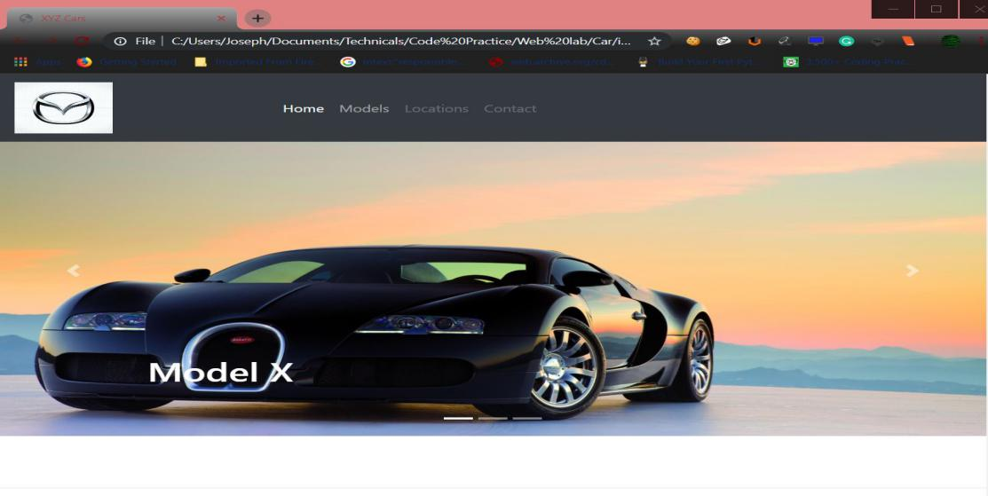

Figure 1: index.html

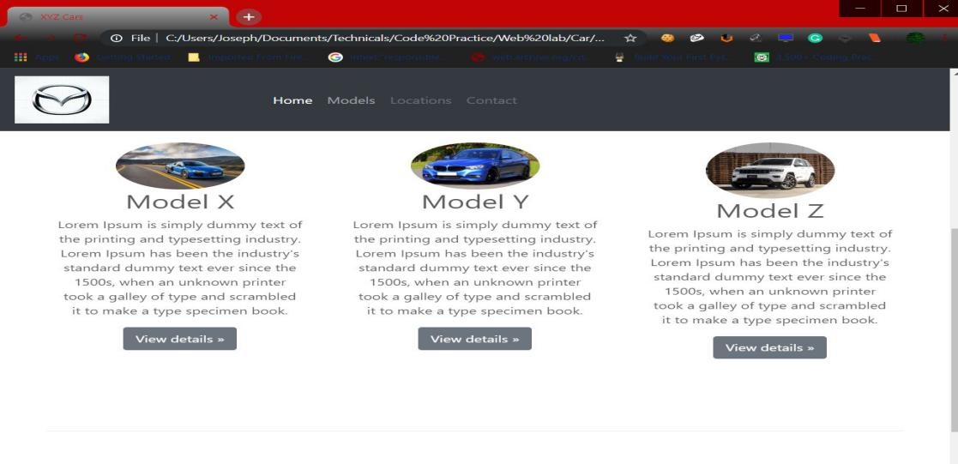

Figure 2: models.html

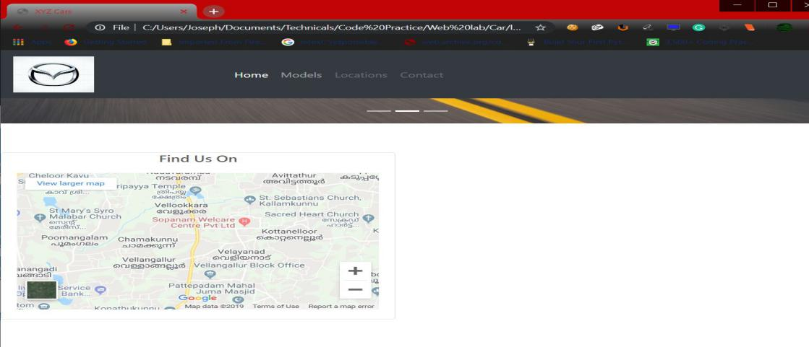

Figure 3: location.html

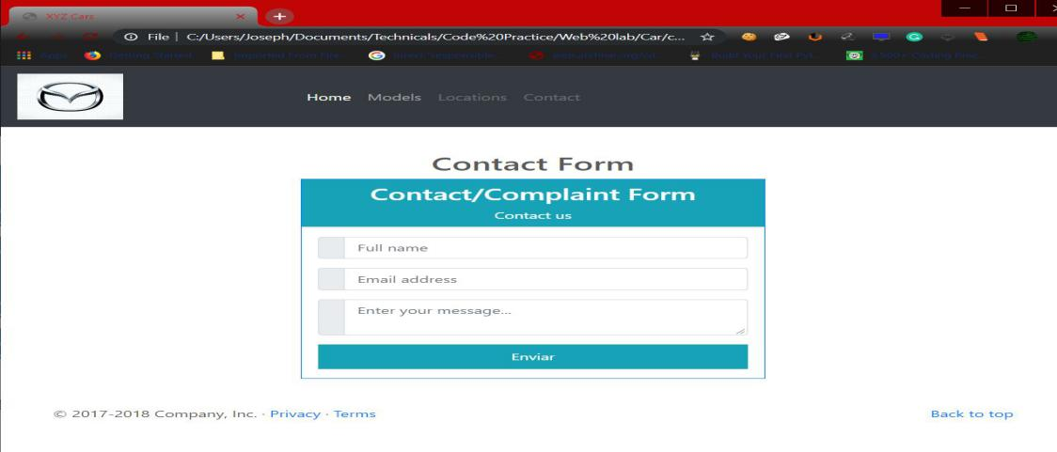

Figure 4: contact.html